# How to get the database structure?

You can get it from source code.

Folder: dbscript/

You can get all database definition.

# How to get the database user/password?

You can get it from source code.

In file WEB-INF/conf/database-config.properties

# What is the develop Tool?

Eclipse

Open source tool

Download from internet

# How to build the project?

Use ant

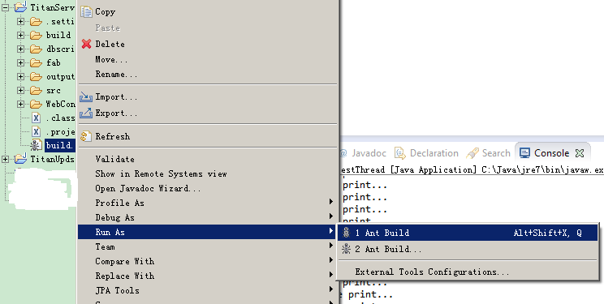

# How to deploy the project?

Use fabric

You can get the fabric code in folder fab/.

Update the configuration file initial.ini .

# What is the web application directory?

App Folder: /var/lib/tomcat7/webapps/

Log Folder: /var/lib/tomcat7/logs/

Tomcat conf files: /var/lib/tomcat7/conf/